BROOKHAVEN NATIONAL LABORATORY
LASER CONTROLLED AREA
STANDARD OPERATING PROCEDURE (SOP)

This document defines the safety management program for the laser system listed below. All American National Standard Institute (ANSI) Hazard Class 3b and 4 laser systems must be documented, reviewed, and approved through use of this form. Each system must be reviewed annually.

System description: 20 Watts CW/pulse fiber-coupled semiconductor diode laser
Location: AGS A3 beamline for E951 experiment

LINE MANAGEMENT RESPONSIBILITIES

The Owner/Operator for this laser is listed below. The Owner/Operator is the Line Manager of the system and must ensure that work with this laser conforms to the guidance outlined in this form.

Owner/Operator:
Name: | Kirk McDonald (Princeton) | Signature: | Date:

AUTHORIZATION
Work with all ANSI Class 3b and 4 laser systems must be planned and documented with this form. Laser system operators must understand and conform to the guidelines contained in this document. This form must be completed, reviewed, and approved before laser operations begin. The following signatures are required.

BNL LSO printed name | Signature | Date
ES&H Coordinator printed name | Signature | Date

APPLICABLE LASER OPERATIONS
x General Operation x Alignment  Service/Repair  Specific Operation x Fiber Optics

ANALYZE THE LASER SYSTEM HAZARDS

Hazard analysis requires information about the laser system characteristics and the configuration of the beam distribution system.

Laser System Characteristics

Laser Type  (Argon, CO2, etc) | Wavelengths | ANSI  Class | Maximum  Power of Energy/Pulse | Pulse Length | Repetition Rate
Semiconductor diode | 808 nm | IV | 20 Watts CW/peak | Variable, 15-150 ns | CW – 1 MHz

Cryogen Use

Describe type, quantity, and use.

none

Chemicals & Compressed Gasses

Describe type, quantity, and use.

none

Electrical Hazards

Description (Describe the power supply to the system).

CW operation – 4 volt dc with 20 Amp maximum current.
Pulsed operation – external trigger at 1 MHz repetition rate with a bunch length (gate width) of 16-microsecond. Trigger runs at one bunch per 5 minutes. Pulse width is set at 150 ns, therefore the duty cycle is 15 %.

Other Special Equipment

Description (Equipment used with the laser(s)).

A Labview interfaced PC controller for the current pulser.

Laser System Configuration: Describe the system controls (keys, switch panels, computer controls), beam path and optics (provide a functional/block diagram for complicated beam paths).

This diode laser itself does not have an ON/OFF power switch. It is driven by a current pulse source, which is remotely controlled using a Labview interface on a local PC. Because of the potential radiation hazard during beam runs within the vicinity of the equipment, the operators access and control the local PC through PC-Anywhere or a Virtual-Network-Interface from a remote PC. Therefore, a remote PC actually controls the laser. The laser itself is in a sealed package, together with the heat sink it is enclosed in an aluminum housing shown in Figure 1.

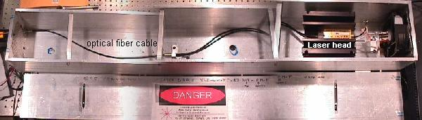
Figure 1

Layout of the optical beam transport in the A3 beamline for experiment E951 is shown in Figure 2 and Figure 3. The thin red line is the fiber optics line and the thick solid red line is the optical beam propagating in free space. The laser beam is fiber-coupled into the radiological controlled area where it is diverged at a full opening angle of 23 degree at the fiber output end. A lens then collimates the diverged light to an area of 6 inch in diameter. A mirror steered the optical beam to a diagnostic port near the mercury target area. The fiber coupling terminates at the lens where the light then travels unenclosed with a spatial beam diameter of 6 inch in diameter and exits through the radiation shielded wall where it terminates on a telescope/CCD camera arrangement. The spatial size of the laser beam is converged to 2-3 inch in diameter at the entrance aperture of the telescope. A second telescope/CCD views the window of the target continuously in real time on an off-axis optical beam path – green/yellow line, no laser light propagates in this beam path.

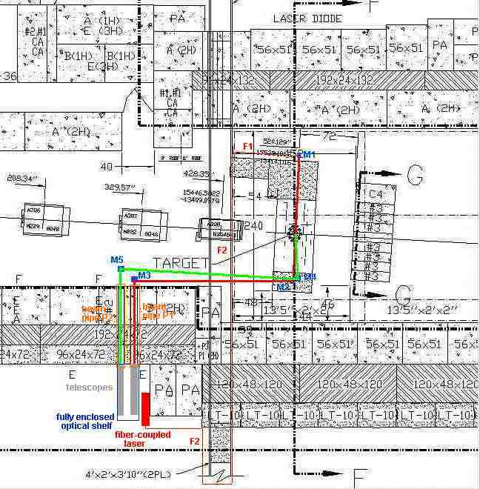
Figure 2
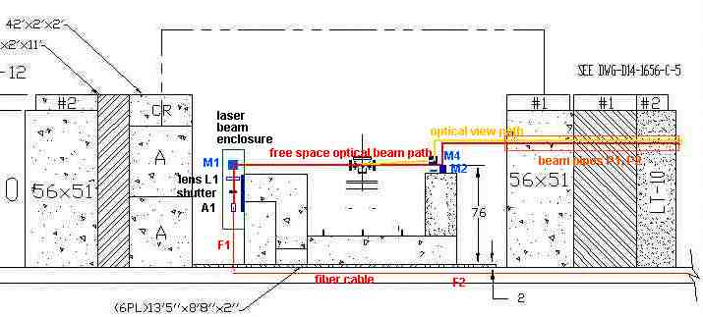
Figure 3

DEVELOP CONTROLS

IDENTIFY ES&H STANDARDS

Recognition, evaluation, and control of laser hazards are governed by the following documents.

American National Standards Institute (ANSI) Standard for Safe Use of Lasers;
(ANSI Z136.1-2000)

Laser Safety Subject Area

Brookhaven National Laboratory Environment Safety and Health Standard: 1.5.3 INTERLOCK SAFETY FOR PROTECTION OF PERSONNEL

ENGINEERING CONTROLS

x Beam Enclosures x Protective Housing Interlocks Other

x Beam Stop or Attenuator Key Controls

Activation Warning System Other Interlocks

Ventilation Emission Delay

Describe each of the controls in the space provided below this text. Interlocks and alarm systems must have a design review and must be operationally tested every six months. Controls incorporated by the laser manufacturer may be referenced in the manuals for these devices. Attach a copy of the design review documentation and a written testing protocol. Attach or keep elsewhere any completed interlock testing checklists to document the testing history.

Engineering Controls Description:

This laser is of Class IV when it operates in CW mode (maximum of 15 Watts), a high current dc power supply is required. When it is operated in the pulsed mode (peak power of 15 Watts in 150 ns pulse width at 1 Hz repetition rate), its classification is lowered to Class IIIb. The laser will not be operated in CW anytime during the experiment and no high current dc power supply is provided. To lower the laser radiation hazard during beam alignment, a low power (1 mWatt) CW red laser diode (Class II laser) is used to align all optics. A metal beam enclosure is placed at the location where the fiber cable couples to the free space optics where laser beam is diverged to the eye level position. A laser interlocked beam shutter is placed at the exit end of the fiber cable. The shutter is interlocked to the entrance gate of the A3 beamline. The location of the interlock switch and the activation button is shown in Figure 4.

To satisfy the laser safety requirement of the AGS operation at the A3 beamline, all optics will be aligned with a Class II laser. For a one-time entrance only (a period of half to one hour), a laser operator will be allowed to enter the A3 cave to perform a final laser beam alignment using the pulsed IR laser under a special Control access mode granted by the AGS safety committee. The laser operator will perform the section 3 of the laser beam alignment inside the cave in the Control access mode with a gate watcher. After final laser beam alignment, upon the exit of the laser operator through the A3 gate, the special Control access mode is terminated. The IR laser can not and will not be operated until A3 cave is ready for proton beam and has went through the Control access procedure. To satisfy such a requirement, the driver of the IR laser and the laser shutter are interlocked to the reset switch of the outer gate. The dry contact (AGS provide) on the reset switch of the outer gate remains open, that is the laser remains disable at all time, until A3 cave is ready for particle beam. When the operation of the gate is in Restricted or Control access modes, the reset contact is open and the laser is disabled.

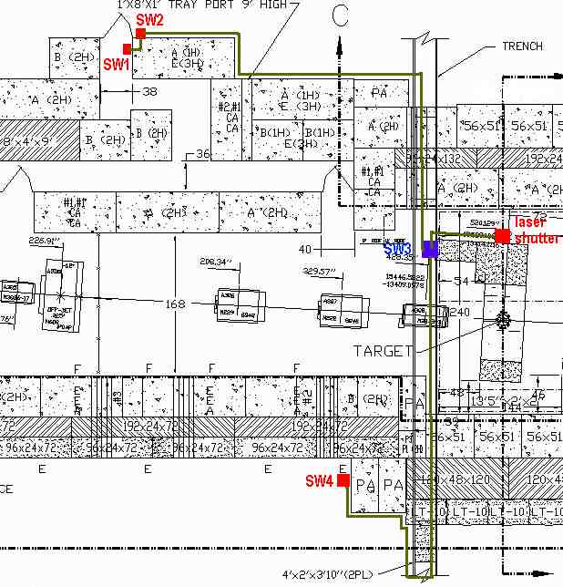
Figure 4

In preparing the laser system for the experiment run, the operation of the laser (and shutter) interlock is described in the following. After CA personnel went through the Control access procedure of the A3 cave and the reset switch of the outer gate has been activated by the operator in the AGS control room,

- Interlock the laser-controlled area by pushing external interlock button on SW2 once, appropriate LEDs will light up on SW2 and SW4. The laser shutter is now enabled and the IR laser can then be powered.
- To open the laser shutter, push SW4 once. Appropriate indicator lights will light up on SW2 and SW4. A flashing laser warning sign at the vicinity of SW4 will be turned on when laser light is emitting.
- Upon completion of the experiment, turn laser off and push SW4 once. Also, the laser power will be disabled when the reset switch is open.

ADMINISTRATIVE CONTROLS

x Laser Controlled Area x Signs x Labels Operating Limits

The format and wording of laser signs and labels are mandated by BNL and ANSI standards. Only the standard signs are acceptable. Standard signs are available from the BNL Laser Safety Officer.

All lasers must have a standard label indicating the system’s wavelength, power, and ANSI hazard class. Required labels must remain legible and attached. The manufacturer should label commercial systems.

Standard Operating Procedures (SOP) are required for laser system operation, alignment, and maintenance. The SOPs need only contain the steps necessary to perform these tasks and identify when and where posting and personal protective equipment is required. SOPs must be approved by the BNL Laser Safety Officer and should be kept with this program documentation.

Administrative Controls Description:

Laser warning labels are placed at the entrance gates of the A3 beamline. A flashing laser warning sign is placed at the vicinity of the optical setup around the East side of the A3 cave. The telescopes and the CCD cameras are enclosed in a metal frame. All E951 personnel are briefed about the laser hazard and the safe operation of the laser. At least one qualified laser operator should be at the control console when any one member of the E951 personnel operates the console. Laser beam alignment is done by qualified, trained, laser operators. In E951 experiment only two qualified laser operators, Thomas Tsang and Harold Kirk, are allowed to align and manipulate the optics.

There are 4 sections of optical alignment procedures.

The first procedure is proceeded from the beam pipe P1, where the telescope is located, to the fiber-optic assemble A1.
- Shine a low power (1 mW ) red laser diode at the center of the beam pipe, P1, to the final turning mirror, M3.
- Align red laser beam from M3 to M2.
- Align red laser beam from M2 to M1.
- Align red laser beam from M1 to the center of L1 and onto the center of the fiber-optic cable launch assembly, A1.
- Plug the exit end of the beam pipe, P1, with metal disk.

The second procedure is proceeded from the fiber-optic assemble A1 back to the beam pipe P1.
- Connect a fiber coupled 1 mW red laser diode to the entrance end of the jumper fiber cable F1.
- Adjust the focusing of the lens L1 until an optimum focusing condition is obtained on P1.
- Make any necessary mirror adjustment to center the beam on P1.

The third procedure is done using the IR laser operated in pulse mode. A laser operator is allowed to enter the cave in a special Control access mode with gate watcher
- Interlock and secure the laser-controlled area. Wear laser protective goggles.
- Disconnect the fiber-coupled red laser diode from fiber cable F1.
- Connect fiber cable F2 to F1.
- Operate the IR laser in pulse mode at –10 volt (5 Watt peak optical power output).
- Make all necessary minor optical adjustment to send IR beam from A1 to the center of the beam pipe P1.
- Confirm the beam alignment by viewing the IR beam using an IR fluorescence card or an IR handheld viewer.

Laser alignment is done.

The last procedure is to align a second telescope for off-axis viewing the target window.
- Shine a low power (1 mW ) red laser diode at the center of the beam pipe, P2, to the turning mirror, M5.
- Align red laser beam from M5 to M4 and onto the center of the target.

All optical alignment is done.

Because the laser diode is packed in a completely sealed package, no laser maintenance or service is required. However, the optical alignment may need to be checked periodically by following the second alignment procedure with a low power red diode laser.

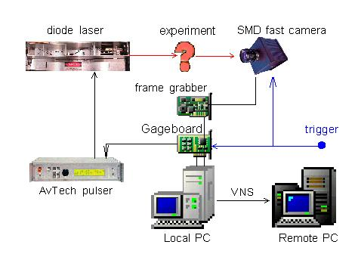
The optical setup of the E951 experiment is shown in Figure 5.
Figure 5

A trigger signal is derived from the fiber-optics trigger light pulse. It is then converted to an electronic TTL signal – G10 trigger. The G10 signal triggers a SR 535 digital delay box. After some appropriate delay set on the delay A, the output A is then sent to the East side wall to trigger the Gage CompuGen 1100 PC board and the fast camera shown in Figure 5. Upon the arrival of the proton beam, the Gage board generates a 16-pulse train per proton bunch. Each pulse has a 0.5 microsecond duration in one microsecond period (when it is operating in 1 million/sec frame rate). The electrical pulse train is then used to trigger the Avtech current pulser. The operating procedures are (sample front panel is shown below):
- Double click on the E951-optics icon displayed on the desktop, double click on the Start-Electronic-trigger icon. A CgWin window will pop-up.
- Click Waveform Editor.
- Open signal files in D:\E951-optics directory: GaGe-1-pulse-1-us.sig for 16-pulse 1 microsecond period, GaGe-1-pulse-10-us.sig for 16-pulse 10 microsecond period, and GaGe-1-pulse-100-us.sig for 16-pulse 100 microsecond period etc.. For frame rate longer than 100 us, open the corresponding eqn file instead and then view the equation.
- Expand and view the single signal waveform.
- Select Setting – Trigger Setting – External.
- Select Setting – Loop Setting – Multishot – 16.
- Click GEN button on the Waveform Editor panel to generate and output the waveform.

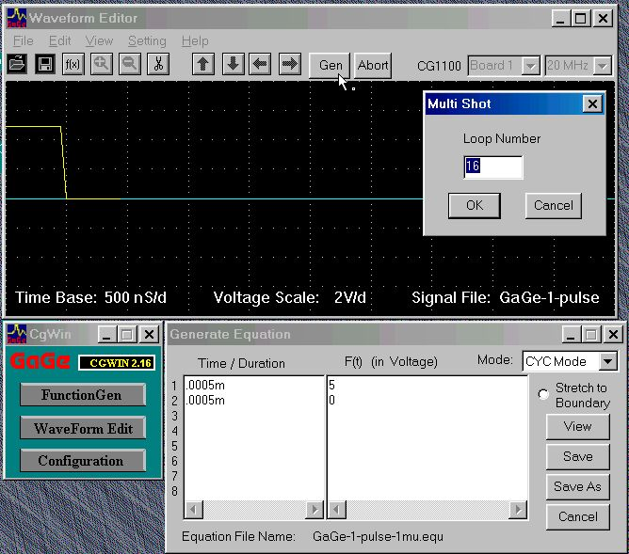
Figure 6

The same trigger pulse mentioned in the previous section is also used to trigger a fast CCD camera, SMD-64K1M, upon the arrival of the proton beam. This camera has a dynamic range of 11-12 bit (4096) of resolution. Its operating procedures are (sample front panel is shown below – Figure 7):
- Double click on the E951-optics icon displayed on the desktop, double click on the Start-fast-camera icon. A IMAP window will pop-up.
- Click Acquire (the icon with a camera) once. System will then initiated.
- Set Ext. Trig. to SYNC, Integ. Time to 0.001, gain to 1.0, and pause time to 0.
- Go to the main display menu. Select Tool-Options-Nonstop acquire display-image statistics submenu. Confirm the Show Histogram and Show General Statistics boxes are unchecked. Confirm Auto Scaling, Scale to Min/Max, Fit to Window, and Log Scale boxes are checked. On the Save submenu, confirm Enable saving of subregion, Convert Pixel Depth (set to 12-Bits), Scale Images boxes are checked. Click OK.
- Double click on the Acquire button (icon with the camera). Acquire Parameter menu will pop-up.
- The following action will acquire images whenever trigger arrives with automatic file saving. Confirm Allow User Cancel box is checked. Confirm the Stack Frms box is checked and Frms # is set to 1. Do not check the Non-stop Acquire box. Select Save Option to Auto Save and type in the complete file name and its directory in the Save Options box . Click OK. Camera is now ready to acquire images and is awaiting the trigger signal to arrive. All 16 (17) images will be displayed on a new window upon the arrival of a trigger pulse and the file will be saved automatically with a file name displayed on the window. The file name and the image will be undated when the subsequent trigger pulses arrive.

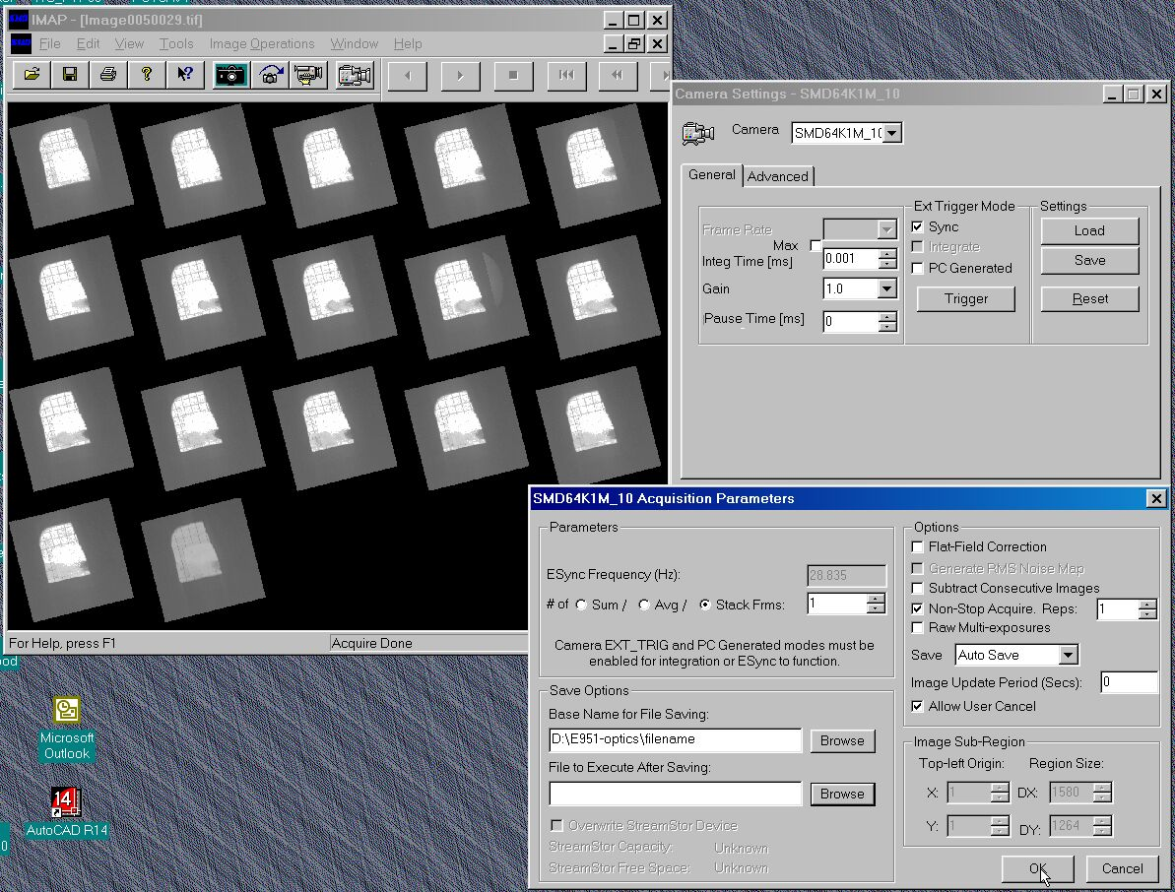
Figure 7

The laser diode is driven by an Avtech current pulser model # AVOZ-A1A-B-N. This pulser is controlled by a LabView interface via an IEEE bus and is triggered by the output pulse train from the Gage board. The operating procedures of the laser driver are (sample front panel is shown in Figure 8):
- Double click on the E951-optics icon displayed on the desktop, double click on the Start-laser-trigger. An Avtech-pulse.vi will initiate and its vi panel will pop-up.
- Confirm IEEE address set to 8.
- Confirm output voltage level set to –20 volt (max. intensity) One can lower the laser intensity by lowering the voltage, see Figure 10 for detail.
- Confirm trigger set to External.
- Confirm pulse width set to 150 ns.
- Initiate the pulser by running the vi once.
- When we are ready for proton beam run. Click the Output Status button to LASER ON and run the vi.
- Laser is now ON. The Laser ON sign on the front panel of the AvTech-pulse.vi will light up to red, and a Danger - Laser ON sign will light up on the East side laser station. The laser will be firing 16-pulses, 150 ns duration per pulse upon the arrival of the proton beam.

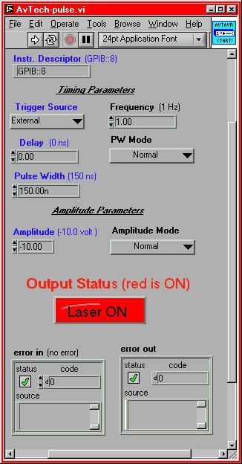
Figure 8

The system is now ready for the experiment. Display all front panels on the monitors as shown in Figure 9 and activate the VNS (virtual-Network-Computing) interface.

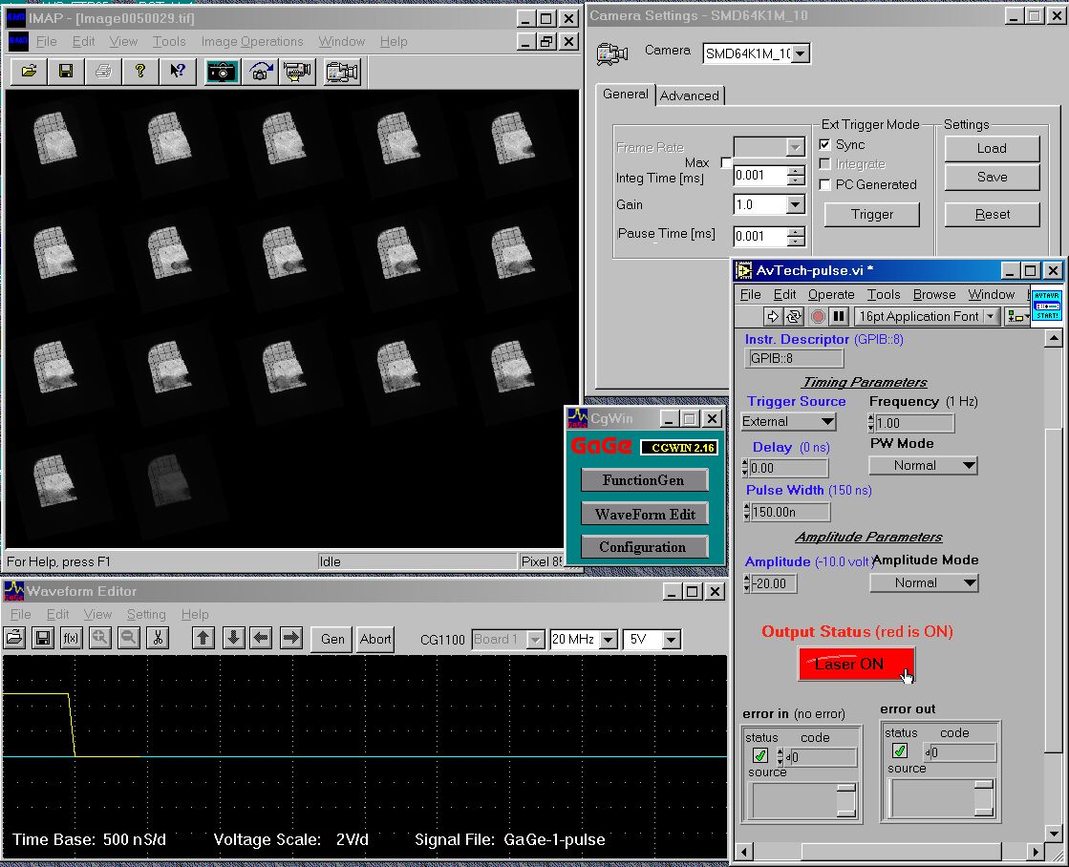
Figure 9

To run the VNC interface on another PC:
- run VNC viewer on the remote PC
- type in the IP address of the local PC: 130.199.96.71
- enter the password
- The screen of the local PC will be displayed on the remote PC in a few seconds

System shut down procedures:
- Confirm all image files are saved in the desired directory.
- Turn the laser off by clicking the Output Status on the Av-Tech-pulse vi front panel once, the Laser On light will turn off. Run the vi. (note: laser will not turn off without running the vi)
- Click Abort on the Waveform Editor panel to stop the laser trigger.
- Close the IMAP (fast camera) panel, the Av-Tech-pulse vi panel, and the CgWin panel.

The time delay between the trigger pulse arriving at the East wall (laser station) to the capturing of the first (microsecond) image is on the order of 1 microsecond.

Detail on the characteristics of the laser is given in the following. Although this laser unit has 2 identical laser diodes each capable of emitting 7 Watt of power, only one laser diode is in used (bottom laser diode). The dc current-voltage-light and the ac voltage-light characteristics are shown in Figure 10(a). At the maximum pulse voltage of –20 volts, 12 Watts of peak power is emitted. However, the light intensity temporal profile varies with drive voltages, see Figure 10(b), and is of triangular shape.
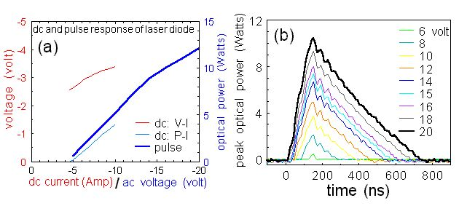
Figure 10

When a 16-pulse train triggers the laser, the intensity of the 16 laser pulses varies, see Figure 11. The light intensity drops by a factor of 2 from the first to the third pulse. This light intensity drooping is also noticeable on the captured image, see Figure 9. However, the temporal shape of all 16 pulse is maintained - triangular. The phenomenon of light intensity drooping and triangular shaped temporal profile is a result of the limited electrical bandwidth of the laser and the limited pulse duration of the voltage driver (maximum of 150 ns).

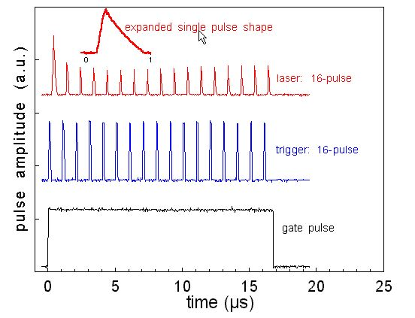
Figure 11

During the experiment if one needs to reduce the number of photons reaching the camera by reducing the pulse width or the pulse voltage of the laser driver, one should aware that either techniques produce nonlinear laser output intensity, as shown in Figure 12.

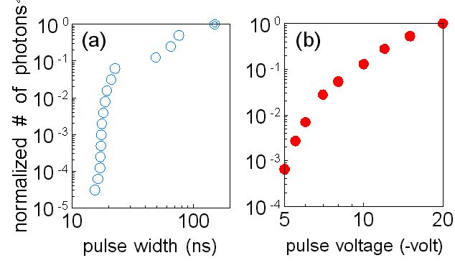
Figure 12

CONFIGURATION CONTROL

Prepare and attach a checklist to be used for configuration control of any protective housings, beam stops, beam enclosures, and any critical optics (mirrors or lenses that could misdirect the beam and result in personnel hazard). Include entries to ensure placement of required signs and labels and status of interlock verification. Completed checklists must be posted at the laser location. The checklist does not have to be redone unless there has been a system modification, extended shutdown, or change of operations.

PERSONAL PROTECTIVE EQUIPMENT

x Eye Wear Skin Protection

Eye Wear: All laser protective eyewear must be clearly labeled with the optical density and wavelength for which protection is afforded. Eyewear should be stored in a designated sanitary location. Color -coding or other distinctive identification of laser protective eyewear is recommended in multi laser environments. Eyewear must be routinely checked for cleanliness and lens surface damage. Skin Protection: For UV lasers or lasers that may generate incidental UV in excess of maximum permissible exposure (MPE), describe the nature of the hazard and the steps that will be taken to protect against the hazard.
EYE WEAR SPECIFICATIONS
Laser System Eyewear  Identification | Wavelengths | Intra-beam  Optical Density | Diffuse  Optical Density
Edmund K53-291 | 808 nm | 3-4
Edmund K38-218 | 635 nm | >5

Define eyewear optical density requirements by calculation or manufacturer reference and list other factors considered for eyewear selection. The BNL Laser Safety Officer will assist with any required calculations.

1. For invisible beams, eye protection against the full beam must be worn at all times unless the beam is fully enclosed.
2. For visible beams, eye protection against the full beam must be worn at all times during gross beam alignment.
3. Where hazardous diffuse reflections are possible, eye protection with an adequate Optical Density for diffuse reflections must be worn within the nominal hazard zone at all times.
4. If you need to operate the laser without wearing eye protection against all wavelengths present, explain the precautions that will be taken to prevent eye injury.

TRAINING

LASER SAFETY TRAINING

Laser Operators must complete sufficient training to assure that they can identify and control the risks presented by the laser systems they use. Owners/Operators and Qualified Laser Operators must complete the BNL World Wide Web based training course (BNL course #HP-IND-011).

Qualified Laser Operators must also complete system-specific orientation with the system owner/operator. System-specific training must be documented with a checklist that includes
- Trainee name and signature
- Owner/Operator signature
- Date
- Brief list of topics covered
- Review of this program documentation
- Review of SOPs

All laser safety training must be repeated every two years.

MEDICAL SURVEILLANCE

Operators of ANSI Class 3b and 4 laser systems must complete a baseline medical eye examination prior to laser system operation. Any qualified ophthalmologist may complete this exam. BNL has arranged for this service from the following local physicians:

Dr. Charles Rothberg The Ophthalmic Center East End Eye Associates
331 East Main St. Dr. Basilice Dr. Sherin
Patchogue, NY 11772 3400 Nesconset Highway 669 Whiskey Road
East Setauket, NY 11733 Ridge, NY 11961

631 758-5300 631 751-2020 631 369-0777
$65 per exam $60 per exam $125 per exam

Personnel using physicians other than those listed must have their examination records forwarded to the BNL Occupational Medicine Clinic.

FEEDBACK AND IMPROVEMENT

Comments and suggestions for improvement should be directed to BNL-Laser Safety Officer, Chris Weilandics (X2593; weil@bnl.gov).

LASER USER QUALIFICATION

Personnel qualified to work with this laser system are listed below. These Qualified Laser Operators must understand the information and conform to the requirements contained in this document. For training and medical surveillance, enter the date of completion.

Qualified Laser Operators:

Basic Laser Training | Job-Specific Training | Medical Surveillance | Printed Name | Signature | Owner/Oper.  Initial/date
10/25/00 | X | 2001 | Thomas Tsang
4/26/99 | X | 1999 | Harold Kirk

Appendix A: Laser interlock test procedure

Two individuals, one stands outside the A3 gate near the SW2 switch and another at the SW4 switch.
Two way radios. One for each individual.
In each step, one person performs task. The other is making observations and reporting back.

Testing laser interlock:
When the A3 gate is not in reset mode, the ac line power of the laser driver is disabled. When the AGS operator reset the A3 gate, the ac line power of the laser can be enabled.
- When the A3 gate is opened by one person the other person should observe the ac power to the laser driver (at SW4 location) drops.
- When the A3 gate is reset by an AGS authorized personnel, the other person should observe the ac power to the laser drive (at SW4 location) enabled.

Appendix B: Shutter testing procedure. (by Marc Montemagno) Not required in this beam run.

Note: In each step, the first person mentioned is the one performing a task. The other two people are making observations and reporting back.

Note: One person should be in charge of running the test, while the other two report back. This is to ensure that no steps are missed.

1. Refer to Figure 6.

2. One person should be placed just within the entrance by SW1, the second just outside the entrance by SW2, the third by the main control panel by SW4.

3. Close door.

4. Check all boxes, SW1, SW2, SW3 and SW4, ensure that all LEDs are off.

5. Person inside – check that the shutter is in the closed position.

6. Person inside – attempt to open the shutter by pressing the shutter open button on SW3. Shutter should not open.

7. Person main unit – attempt to open shutter by pressing the shutter open button on SW4. Shutter should not open.

8. Person inside – press internal interlock button on SW1. Enable and interlock LEDs should light.
Person outside – should only see the interlock LED on SW2. Yellow flashing.
Person main unit – should see all LEDs off.

9. Person inside – go to SW3 and press shutter open button. Blue LED should light and shutter should open.
Person outside – no change.
Person main unit – Blue shutter open LED should light.

10. Person main – press shutter close button. Blue LED should stay on.
Person outside – no change
Person inside – shutter should stay open. Blue LED should stay on.

11. Person inside – close the shutter by pushing the close button on SW3. Blue LED should go out and the shutter should close.
Person main – Blue LED should go out.
Person outside – no change.

12. Person main – press the shutter open button on SW4. Should have no effect.
Person inside – observe that the shutter did not open.
Person outside – no change.

13. Person inside – press the shutter open button on SW3. Blue LED should light.
Person main – Blue LED should light.
Person outside – no change.

14. Person outside – open door. LEDs on both SW1 and SW2 should go out.
Person inside – Shutter should close and both LEDs on SW3 should go out.
Person main – Both LEDs should be off.

15. Person outside – close door. All LEDs should still be out at SW1 and SW2.
Person inside – attempt to open the shutter by pressing the open button. Shutter should remain closed. Both LEDs should still be out on SW3.
Person main – both LEDs should still be out on SW4.

16. Person main – press the shutter open button on SW4. LEDs should remain off.
Person inside – observe that the shutter did not open. LEDs should remain off.
Person outside – ensure that all LEDs remained off on SW1 and SW2.

17. Person outside – press the outside interlock button on SW2. Both LEDs should light on SW2. Interlock LED, flashing yellow, should light on SW1.
Person main – the enable LED should be on, flashing yellow on SW4.
Person inside – Both LEDs should be out on SW3.

18. Person main – press the shutter open button on SW4. Blue LED should light.
Person inside – the shutter should open and the blue LED should light on SW3.
Person outside – no change.

19. Person main – press the shutter close button on SW4. The blue LED should turn off.
Person inside – the shutter should close and the blue LED should turn off.
Person outside – no change.

20. Person inside – press the shutter open button on SW3. The shutter should not open.
Both LEDs should still be out.
Person main – the blue LED should remain off. The enable LED should still blink.
Person outside – no change.

21. Person main – press the shutter open button. The blue LED should light on SW4.
Person inside – the shutter should open and the blue LED should light on SW3.
Person outside – no change.

22. Person outside – open the door. All LEDs should go out on both SW1 and SW2.
Person inside – the shutter should close and all LEDs should be off.
Person main – all LEDs should go out on SW4.

23. Person outside – close door. All LEDs should remain off.
Person inside – all LEDs should remain off. The shutter should remain closed.
Person main – all LEDs should remain off.

24. End of test. Record any discrepancies.

25. Remove red tag from laser system.

Appendix C: Log of Laser interlock test

Date | Laser power interlock(pass/fail) | Laser shutter interlock (pass/fail) | name

