The Muon Collider Target System

H.G. Kirk, Brookhaven National Laboratory, and K.T. McDonald, Princeton University

(July 28, 2011)

- Introduction

The target system consists of a free liquid mercury jet immersed in a high-field solenoid magnet capture system that also incorporates the proton beam dump.

The requirements for a Muon Collider/Neutrino Factory (some of which are summarized in Table 1) call for a target capable of intercepting and surviving a 4-MW, 15-Hz pulsed proton beam.
Table 1.Assumed proton beam parameters.
Proton-beam energy | 8 GeV
Rep rate | 15 Hz
Bunch width | 2 ± 1 ns
Beam radius | 1.2 mm (rms)
Beam power | 4 MW (3.125 × 10¹⁵ protons/sec)

A collider requires simultaneous production/capture of charged pions of both signs, which mandates the use of solenoid magnets in the target system. The target-system concept is illustrated in Fig. 1, in a version slightly modified from Neutrino Factory Study 2.Error: Reference source not found The target, the proton beam dump, and a shield/heat exchanger are to be located inside a channel of superconducting solenoid magnets that capture, confine and transport secondary pions and their decay muon, of energy 100-400 MeV, to the bunching, phase-rotation, cooling and acceleration sections downstream. Most of the 4-MW beam power is to be dissipated within a few meters, inside the solenoid channel, which presents a severe challenge. The present baseline target system includs considerable more shielding of the superconducting magnet near the target, as sketched in the upper part of Fig. 2. Studies of the tradeoffs between capital costs and operational costs including frequency of replacement of irradiated components are ongoing, and the baseline configuration is expected to evolve considerably in the near future.
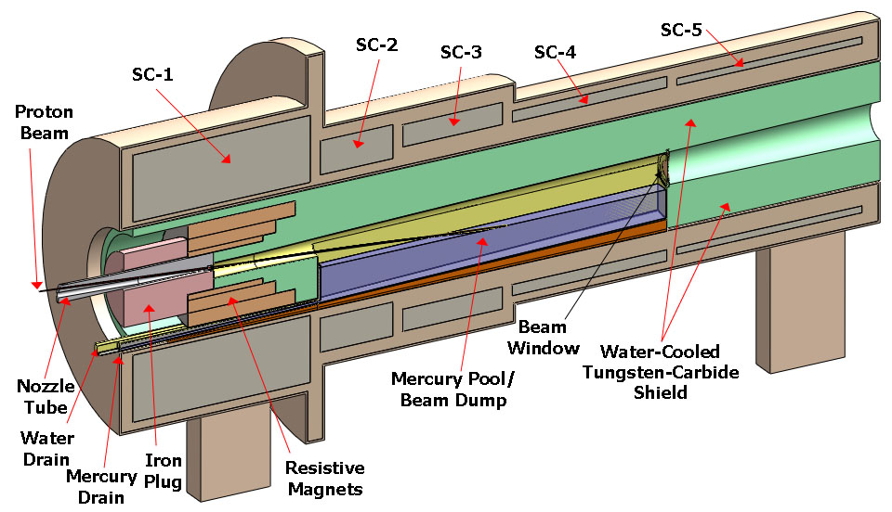

Fig. 1 Target-system concept, with small changes from Neutrino Factory Study II.
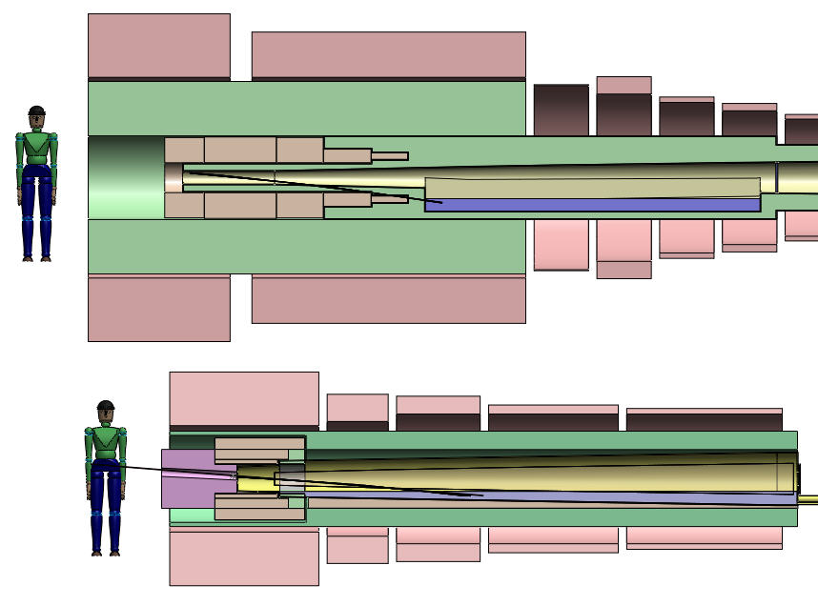

Fig. 2. Comparison of present vision of the target system (top) with that of Neutrino Factory Study II (bottom).

Maximal production of low-energy pions is obtained with a proton beam of 1-2 mm (rms) radius and a target of radius 2.5 times this, such that the secondaries exit the side of the target rather than its end. The resulting high density of energy deposition in the target makes it questionable whether any passive solid target could survive at 4-MW beam power. Schemes for a set of moving solid targets are not very compatible with the surrounding solenoid magnets. Hence, the baseline target concept is for a free liquid jet target, in particular mercury. The present baseline parameters of the target are summarized in Table 2.
Table 2.Baseline target-system parameters
Target type | Free mercury jet
Jet diameter | 8 mm
Jet velocity | 20 m/s
Jet/solenoid-axis angle | 96 mrad
Proton-beam/solenoid-axis angle | 96 mrad
Proton-beam/jet angle | 27 mrad
Capture solenoid field strength | 20 T
Front-end transport channel field strength | 1.5T
Length of transition between 20 T and 1.5 T | 15 m

The target itself is a free liquid mercury jet (Z = 80, A = 200.6, density ρ = 13.5 g/cm³, λ_{I} ≈ 15 cm) of diameter d = 8 mm, flowing at v = 20 m/s. The volume flow rate is 1.0 l/s, and the mechanical power in the flowing jet is 2.7 kW. The flow speed of 20 m/s insures that the gravitational curvature of the jet over 2 interaction lengths (30 cm) is negligible compared to its diameter, and that more than 2 interaction lengths of new target material are present to the beam every cycle of 20 ms (at 50 Hz).

This target concept has been validated by R&D over the past decade, culminating in the so-called MERIT experiment that ran in the Fall of 2007 at the CERN PS. The experiment benefited from the intensity of the beam pulses (up to 30 x 10¹² ppp) and the flexible beam structure available for the extracted PS proton beam. Key experimental results include demonstration that:
- The magnetic field of the solenoid greatly mitigates both the extent of the disruption of the mercury and the velocity of the ejected mercury after interception of the proton beam. The disruption (see Fig. 3) of a 20-m/s mercury jet in a 20-T field is sufficiently limited that operations up to 70-Hz is feasible without loss of secondary particle production.
- Individual beam pulses with energies up to 115 kJ can be safely accommodated.
- Subsequent proton beam pulses separated by up to 350 μsec have the same efficiency for secondary particle production as does the initial pulse.
- Two beam pulses separated by more than 6 μsec disrupt the mercury independently.
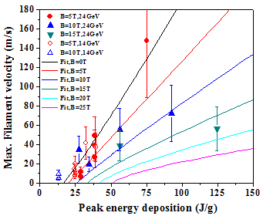
0 T
5 T
10 T
20 T
25 T
Peak energy deposition
at 4 MW, 50 Hz
Curves are global fits
0 T
5 T
10 T
15 T
Curves are global fits

Fig. 3. Disruption length vs. total energy position (left) and filament velocity vs. peak energy deposition as observed in a free mercury jet the MERIT experiment.

The mercury jet is collected in a pool, inside the solenoid magnet channel, that also serves as the proton beam dump, as sketched in Fig. 1. Disruption of this pool by the mercury jet (whose mechanical power is 2.7 kW) and by the noninteracting part of the proton beam is nontrivial, and needs further study.

The superconducting magnets of the target system must be shielded against the heat and the radiation damage caused by secondary particles from the target (and beam dump). A high-density shield is favored to minimize the inner radii of the magnets. The baseline shield concept is for water-cooled tungsten-carbide beads inside a stainless steel vessel (of complex shape, as sketched in Fig. 2).

The magnets of the target system vary in strength from 20 T down to 1.5 T in the subsequent constant-field transport channel, with a corresponding increase in the radius of the capture channel from 7.5 cm to 30 cm.

A 20-T field is beyond the capability of Nb₃Sn, so the 20-T coil set is proposed as a hybrid of a 15-T superconducting coil outsert with a 5-T hollow-core copper solenoid insert. A 45-T solenoid of this type of construction has been operational since 2000 at the National High Magnetic Field Laboratory (Florida), and a 19-T magnet of this type with 16-cm-diameter bore exists at the Grenoble High Magnetic Field Laboratory (and was used in an earlier phase of our R&D program). A topic for further study is possible fabrication of the 20-T magnet with high-T_{C} superconductor and no copper solenoid insert, which could provide more space for internal shielding of the superconducting coils and/or permit operation at a higher field for improved reduction of the initial beam emittance.

The target system (and also the subsequent π/μ solenoid transport channel) will be subject to considerable activation, such that once beam has arrived on target all subsequent maintenance must be performed by remote-handling equipment. The infrastructure associated with the target hall, with its remote-handling equipment, and hot-cells for eventual processing of activated materials, may be the dominant cost of the target system.

References

The intense pressure waves in a liquid target due to a pulsed beam lead to damage/failure of any pipe that contains the liquid in the interaction region. Thus, the baseline is for a free liquid jet.
The target system is defined to end where the subsequent constant-field capture channel begins, at z =15 m downstream of the downstream end of the beam-jet interaction region (z = 0)..
M.M. Alsharo’a et al., Status of Neutrino Factory and Muon Collider Research and Development and Future Plans, Phys. Rev. ST Accel. Beams 6, 081001 (2003), http://puhep1.princeton.edu/~mcdonald/examples/accel/alsharoa_prstab_6_081001_03.pdf
S. Ozaki et al., Feasibility Study II of a Muon-Based Neutrino Source (June 14, 2001), http://www.cap.bnl.gov/mumu/studyii/FS2-report.html
X. Ding et al., A Pion Production and Capture System for a 4 MW Target Station, IPAC10, http://www.hep.princeton.edu/~mcdonald/mumu/target/ipac10/thpec092.pdf
J.R.J. Bennett et al., Studies of a Target System for a 4-MW, 24-GeV Proton Beam, proposal to the ISOLDE and Neutron Time-of-Flight Experiments Committee, CERN-INTC-P-186 (April 26, 2004), http://www.hep.princeton.edu/~mcdonald/mumu/target/cern_proposal.pdf
K.T. McDonald et al., The MERIT High-Power Target Experiment at the CERN PS, PAC09, http://www.hep.princeton.edu/~mcdonald/mumu/target/pac09/tu4gri03.pdf
45-T Hybrid, NHMFL, http://www.magnet.fsu.edu/mediacenter/features/meetthemagnets/hybrid.html
Magnet M8, GHMFL, http://ghmfl.grenoble.cnrs.fr/spip.php?rubrique77&lang=en
A. Fabich, High Power Proton Beam Shocks and Magnetohydrodynamics in a Mercury Jet Target for a Neutrino Factory, Ph.D. thesis (U. Vienna, Nov. 2002), http://www.hep.princeton.edu/~mcdonald/mumu/target/thesis-2002-038.pdf

