Face-Cooling of Beryllium Window at z = 3 m in Magnet IDS120h
Bob Weggel, M.O.R.E., LLC
December 24, 2011

This report analyzes the face-cooling—by water or helium gas—of a beryllium window at z = 3 meters in Magnet IDS120h with the power density distribution reported in Nick’s file “IDS120hm_BeWind_TDP_NO_SH1_NP100000_nx20_ny20_nz1_a.txt” (e-mail of 12/1/’11, 1:37 AM). The maximum power density (in a voxel at –1, +0.7) is 103 W/g—i.e., 190 W/cm³ for beryllium, which has a density of 1.85 g/cm³. The power deposition is highly localized. At a power density of 190 W/cm³ the total deposited power (TDP) in a disk only 7 cm in diameter would equal the 7,400 W/cm that Nick reports for the full 30-cm-diameter beryllium window.
[Caveat: Nick’s file “IDS120hm_BeWind_TDP_NO_SH1_NP100000_nx40_ny40_nz1_a.txt” reports an even-higher maximum power density (at −0.50, 1.75) of 201 W/g, or 372 W/cm³.]
Figure 1 plots two candidate models of Nick’s data. Each simultaneously duplicates his predicted total power and maximum power density (postulated to occur at r = 0). The dashed red curve is an inverse polynomial, q(r) = q₀ a²/(a²+r²). The parameter q₀ is the maximum power density, 190 W/cm³, noted above. 2 π r q(r) integrates to a total power Q(r) = π q₀ a² ln(1+r²/a²). Equating this expression, evaluated at r = 15 cm, to Nick’s value of 7,400 W/cm for total deposited power, yields a value of 1.68 cm for the parameter “a”. The dashed magenta curve of Fig. 1 plots the consequent power-density distribution. An alternative distribution is the solid red curve of Fig. 1, an exponential, q(r) = q₀ (1−r/a) exp^{−r/a}, with a = 1.44 cm, that integrates to Q(r) = 2π q₀ [3a²−(3a²+3ar+r²)e^{−r/a}], the solid magenta curve of Fig. 1. The analyses of this report employ the exponential distribution.
Table I predicts the thickness of beryllium that can be cooled with helium, water or mercury while limiting the maximum temperature in the beryllium to 80°C above that of the incoming helium. In general, the temperature rise ∆T = ∆T_{bulk} + ∆T_{b.l.} + ∆T_{Be}, where ∆T_{bulk}, ∆T_{b.l.} and ∆T_{Be} are the respective temperature rises: 1) within the helium; 2) across the boundary layer between the helium and the beryllium; and 3) within the beryllium itself. If the cooled face of the window is the [x,y] plane, and the helium flow is in the x direction, then the maximum temperature rise ∆T_{max} will occur at [x, 0, t], where t is the thickness of the beryllium.
Define ∆T⁰ to be the maximum boundary-layer temperature rise—which will occur at x = 0, where the power density q(r) is greatest. Define ∆T^{R} to be the maximum bulk temperature rise—which will occur at x = R, the downstream end of the window diameter aligned with the helium flow. If ∆T^{R} << ∆T⁰, then x ≈ 0. If ∆T^{R} >> ∆T⁰, then x ≈ R. At x = 0, ∆T_{max} = ∆T^{R}/2 + ∆T⁰ + ∆T⁰_{Be}, where ∆T⁰_{Be} is ∆T_{Be} evaluated at x = 0. At x = R, where q(r) ≈ 0, the maximum temperature rise ∆T_{max} ≈ ∆T^{R}.
The first thirteen columns of Table I are for helium; the next three are for water; the last column is for mercury. Water, because of its outstanding heat capacity, needs only a thin layer of coolant to keep ∆T^{R} small. Water only 2 mm deep (hydraulic diameter = 4 mm) at a velocity of 18.5 m/s warms only 1.6°C if heated over a length of 7 cm, the effective diameter of the beryllium window. With ∆T⁰ = 40.4°C, the temperature limit of 80°C allows a temperature rise ∆T⁰_{Be} in the beryllium of 80−40.4−1.6/2 = 38.8°C. For a power density of 190 W/cm³, this corresponds to a beryllium thickness of 9 mm, 70% of the maximum thickness, 13 mm, that could be cooled with perfect face-cooling.
For helium, the third column is a base case, for which the helium pressure is 5 bars (~5 atmospheres), the hydraulic diameter is 2 cm, and the velocity is 144 m/s, achievable with a pressure drop of 20 kPa (4% of the ambient pressure) in a passage 1 meter long. This assumed passage length is 3⅓ times the diameter of the beryllium window itself, to allow for pressure losses in getting to and from the window.
Columns 1 through 5 predict the thickness of beryllium with hydraulic diameters from 1 cm to 3 cm—i.e., the layer of helium that cools the beryllium has a thickness of 5 mm to 15 mm. Increasing the passage height threefold increases by a factor of 2.3—from 3.2 mm to 7.4 mm—the beryllium thickness permitted by the postulated constraint of a maximum temperature rise of 80°C. The increase arises from the threefold improvement in heat-transfer coefficient—from 1.1 to 3.2 W/(cm² K)—arising from the fourfold increase in Reynolds number, from 47,000 to 188,000. This in turn arises from the threefold increase in hydraulic diameter and 34% increase in velocity, from 116 m/s to 156 m/s.
The next four columns restore the base values of hydraulic diameter and helium-pressure-drop percentage but vary the helium pressure from 1 bar to 10 bars. A tenfold increase in helium pressure increases the permissible thickness of beryllium by a factor of 4.7 (8.2 mm/1.7 mm), attributable mostly to the tenfold increase in helium heat capacity per unit volume.
The next four columns vary the pressure-drop percentage by a factor of three, from 2% to 6%. The permissible beryllium thickness increases by a factor of only 6.6/4.7 = 1.4, because the only source of improvement is a factor of 1.8 increase in helium velocity. Figure 2 plots the results highlighted in the previous four paragraphs.
Table I and Fig. 2 ignore radial conduction of heat; Fig. 3 suggests the validity of this simplification by revealing the minimal increase in maximum temperature in a beryllium window that results from isolating its heated zone (of 7 cm diameter, as in paragraph #1) from the rest of the disk outside it.
A complication in estimating analytically the temperature rise in the helium, for input to the FEM program for predicting the other temperature rises, is that the power-density distribution q(r) is axisymmetric but the helium flow is not. To estimate the bulk temperature rise of the helium as a function of position [x, y], assuming negligible tangential heat flow in the beryllium, requires integrating q(r) dx. An approximation to the integrand that closely resembles the original for x = 0 and for y = 0 is q₀ (1+x/c) e^{−x/c} (1+y/c) e^{−y/c}. Here the parameter c = 1.56 cm instead of 1.44 cm, in order that the integral over the entire window yield 7,400 W/cm. Integration from 0 to x yields q₀ (1+y/c) e^{−y/c} {1−[1+x/(2c)] e^{−x/c}}. Integration from –∞ to x gives ∆T(x, y) = ½ ∆T^{R} (1+y/c) e^{−y/c} {2−[1+x/(2c)] e^{−x/c}}.
The thermal strains created by the non-axisymmetric temperature distribution may distort the beryllium window. If this is likely to give problems, then it may be useful to stiffen the window with ribs or make the window progressively thicker as permitted by the decrease in power density with increasing radius. Such stiffening may be necessary to resist the pressure from the coolant fluid. A double window, with each member of the pair braced by its partner via ribs that cross the midplane, may simultaneously greatly decrease the distortion of each window and decrease the boundary-layer temperature rise in the window by utilizing the surface area of the ribs.

Fig. 1: Exponential (solid-line) & inverse-polynomial (dashed-line) curve fits to power density, q(r), & total deposited power, TDP, in 1-cm-thick beryllium window at z = 3 meters in Magnet IDS120h. For each curve, q_{max} = q(r=0) ≡ q₀ = 190 W/cm³, and TDP (r=15cm) = 7,400 W/cm.

Table I: Coolant Velocity & Beryllium Thickness to Limit Peak Temperature Rise to 80°C in Be Window Heated as in Red Curve of Fig. 1.
 |  |  | He | He | He | He | He | He | He | He | He | He | He | He | He | H₂0 | H₂0 | H₂0 | Hg
Pressure (bar; ~atm) |  | bar | 5.0 | 5.0 | 5.0 | 5.0 | 5.0 | 1.0 | 2.5 | 7.5 | 10.0 | 5.0 | 5.0 | 5.0 | 5.0 | 5.0 | 5.0 | 5.0 | 10.0
Density | ρ | kg/m³ | 0.813 | 0.813 | 0.813 | 0.813 | 0.813 | 0.163 | 0.406 | 1.219 | 1.626 | 0.813 | 0.813 | 0.813 | 0.813 |  |  |  | 13579
Density @ 300 K | ρ | kg/m³ | 0.800 | 0.800 | 0.800 | 0.800 | 0.800 | 0.160 | 0.401 | 1.199 | 1.597 | 0.800 | 0.800 | 0.800 | 0.800 | 997 | 997 | 997 | 13562
Desired pressure drop | ∆P | kPa | 20.0 | 20.0 | 20.0 | 20.0 | 20.0 | 4.0 | 10.0 | 30.0 | 40.0 | 10.0 | 15.0 | 25.0 | 30.0 | 500 | 500 | 500 | 1000
Assumed velocity | m/s | m/s | 116 | 133 | 144 | 151 | 156 | 133 | 139 | 146 | 148 | 100 | 124 | 161 | 177 | 14.1 | 18.5 | 20.6 | 7.44
Assumed velocity | mph | Mph | 260 | 298 | 322 | 337 | 348 | 296 | 312 | 327 | 330 | 224 | 277 | 361 | 397 | 31.6 | 41.3 | 46.0 | 16.6
Velocity head, ∆P_{head} | 16.4 | kPa | 5.51 | 7.25 | 8.43 | 9.26 | 9.87 | 1.44 | 3.97 | 13.0 | 17.7 | 4.09 | 6.25 | 10.6 | 12.8 | 101 | 173 | 215 | 382
Percent of pressure drop | 7.76 |  | 1.10 | 1.45 | 1.69 | 1.85 | 1.97 | 1.44 | 1.59 | 1.74 | 1.77 | 0.82 | 1.25 | 2.13 | 2.57 | 20.2 | 34.7 | 42.9 | 38.2
Hydraulic diameter, D_{h} | 1.70 | cm | 1.00 | 1.50 | 2.00 | 2.50 | 3.00 | 2.00 | 2.00 | 2.00 | 2.00 | 2.00 | 2.00 | 2.00 | 2.00 | 0.20 | 0.40 | 0.60 | 0.40
Viscosity | μ | μPa•s | 19.6 |  |  |  |  |  |  |  | 0.640 |  |  |  |  | 856 | 856 | 856 | 1500
Viscosity @ 300 K | μ | μPa•s | 19.9 | 19.9 | 19.9 | 19.9 | 19.9 | 19.9 | 19.9 | 19.9 | 19.9 | 19.9 | 19.9 | 19.9 | 19.9 | 833 | 833 | 833 | 1577
Reynolds number | x10³ | ρ v D_{h} /μ | 46.7 | 80.4 | 116 | 151 | 188 | 21.3 | 56.1 | 176 | 237 | 80.5 | 99.5 | 130 | 143 | 33.7 | 88.3 | 147.5 | 256
Friction factor | f | - - | 0.021 | 0.019 | 0.017 | 0.017 | 0.016 | 0.026 | 0.020 | 0.016 | 0.015 | 0.019 | 0.018 | 0.017 | 0.017 | 0.023 | 0.018 | 0.017 | 0.015
Length of passage | L_{hyd} | M | 1.0 | 1.0 | 1.0 | 1.0 | 1.0 | 1.0 | 1.0 | 1.0 | 1.0 | 1.0 | 1.0 | 1.0 | 1.0 | 0.3 | 0.3 | 0.3 | 0.3
Pressure-drop error | 0.00 | % | 0.0 | 0.0 | 0.0 | 0.0 | 0.0 | 0.0 | 0.0 | 0.0 | 0.0 | 0.0 | 0.0 | 0.0 | 0.0 | 0.0 | 0.0 | 0.0 | 0.0
Heat capacity @ 300 K | C_{p} | kJ/(K•m³) | 4.16 | 4.16 | 4.16 | 4.16 | 4.16 | 0.83 | 2.08 | 6.23 | 8.30 | 4.16 | 4.16 | 4.16 | 4.16 | 4180 | 4180 | 4180 | 1885
Thermal cond. @ 300 K | K | mW/(K•m) | 154.6 | 154.6 | 154.6 | 154.6 | 154.6 | 154.0 | 154.2 | 155.0 | 155.3 | 154.6 | 154.6 | 154.6 | 154.6 | 600 | 600 | 600 | 8690
Computed Prandtl number | Pr | Cp μ / ρ k | 0.669 | 0.669 | 0.669 | 0.669 | 0.669 | 0.672 | 0.671 | 0.668 | 0.666 | 0.669 | 0.669 | 0.669 | 0.669 | 5.83 | 5.83 | 5.83 | 0.025
Reported Prandtl number | Pr | - - | 0.671 | 0.671 | 0.671 | 0.671 | 0.671 | 0.672 | 0.672 | 0.671 | 0.670 | 0.671 | 0.671 | 0.671 | 0.671 | 5.93 | 5.93 | 5.93 | 0.0241
Dittus-Boelter coefficient | h | W/(K•cm²) | 1.07 | 1.65 | 2.20 | 2.73 | 3.24 | 0.57 | 1.24 | 3.08 | 3.91 | 1.65 | 1.95 | 2.42 | 2.61 | 1.97 | 4.25 | 6.40 | 1.10
Power density | w_{v} | W/cm³ | 190.0 | 190.0 | 190.0 | 190.0 | 190.0 | 190.0 | 190.0 | 190.0 | 190.0 | 190.0 | 190.0 | 190.0 | 190.0 | 190.0 | 190.0 | 190.0 | 190.0
Wall thickness, t₀ |  | cm | 0.322 | 0.471 | 0.586 | 0.675 | 0.743 | 0.173 | 0.368 | 0.723 | 0.815 | 0.472 | 0.538 | 0.624 | 0.655 | 0.623 | 0.904 | 1.018 | 0.406
Percent coolant |  | % | 60.8 | 61.4 | 63.0 | 64.9 | 66.9 | 85.2 | 73.1 | 58.0 | 55.1 | 67.9 | 65.0 | 61.6 | 60.4 | 13.8 | 18.1 | 22.8 | 33.0
Heat flux density at x=0 | w_{s} | W/cm² | 61.2 | 89.6 | 111 | 128 | 141 | 32.9 | 70.0 | 137 | 155 | 89.7 | 102 | 119 | 125 | 118 | 172 | 193 | 77.2
Coolant flow rate per cm | Q | lit/(s cm) | 2.91 | 5.00 | 7.19 | 9.41 | 11.7 | 6.63 | 6.97 | 7.30 | 7.38 | 5.01 | 6.19 | 8.07 | 8.87 | 0.071 | 0.185 | 0.308 | 0.074
Length of heated zone | L_{heated} | cm | 7.0 | 7.0 | 7.0 | 7.0 | 7.0 | 7.0 | 7.0 | 7.0 | 7.0 | 7.0 | 7.0 | 7.0 | 7.0 | 7.0 | 7.0 | 7.0 | 7.0
Bulk temperature rise | ∆T_{bulk} | °C | 35.4 | 30.1 | 26.1 | 22.9 | 20.4 | 41.7 | 33.8 | 21.1 | 17.7 | 30.1 | 27.8 | 24.7 | 23.6 | 2.8 | 1.6 | 1.1 | 3.9
Boundary-layer temp. rise | ∆T_{b.l.} | °C | 57.4 | 54.4 | 50.6 | 46.9 | 43.6 | 57.7 | 56.7 | 44.6 | 39.6 | 54.4 | 52.3 | 49.1 | 47.8 | 60.2 | 40.4 | 30.2 | 70.2
Conduction temp. rise, ∆T_{c} | 2.00 | W/(K•cm) | 4.9 | 10.6 | 16.3 | 21.6 | 26.3 | 1.4 | 6.4 | 24.8 | 31.5 | 10.6 | 13.8 | 18.5 | 20.4 | 18.4 | 38.8 | 49.2 | 7.8
Hot-spot temperature rise | ∆T_{max} | °C | 80.0 | 80.0 | 80.0 | 80.0 | 80.0 | 80.0 | 80.0 | 80.0 | 80.0 | 80.0 | 80.0 | 80.0 | 80.0 | 80.0 | 80.0 | 80.0 | 80.0

Fig. 2: Be thickness [mm], He velocity [m/s] & bulk, boundary-layer & gradient temperature rises [°C] in Be window heated as in solid red curve of Fig. 1: q(r) = 190 (1 + r/c) e^{−r/c} W/cm³, where c = 1.44 cm. Circles: He pressure [bars]; triangles: He-layer thickness [mm]; squares: He pressure drop [kPa]. Red curves: He velocity [m/s]; black: Be thickness [mm]; blue, turquoise & green curves: bulk, boundary-layer & Be ∆T’s [°C].
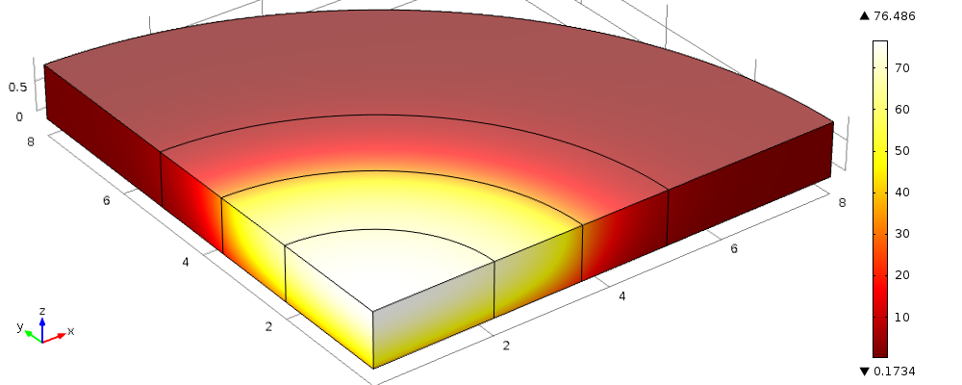

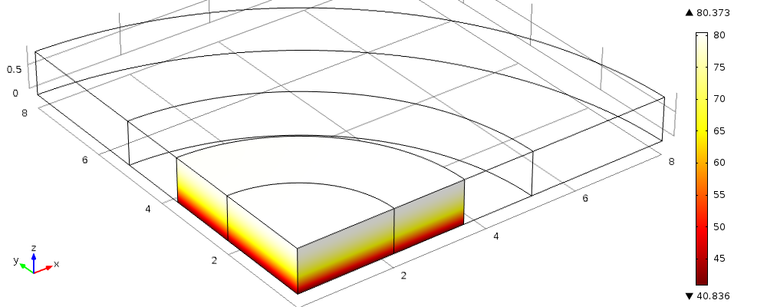

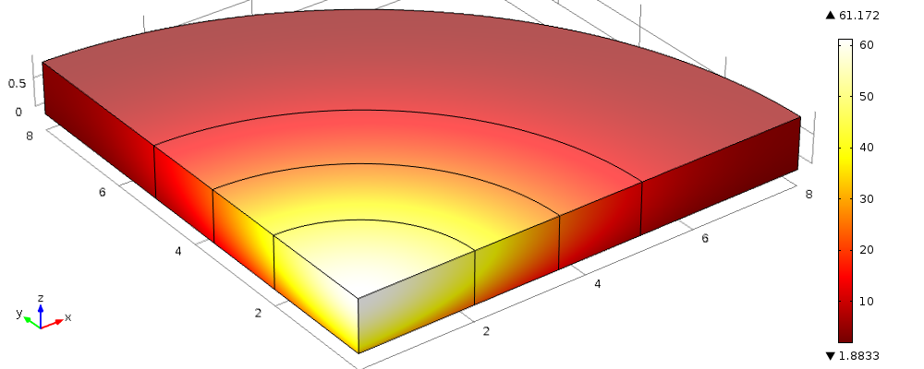
Figs. 3a-c: ∆T in quadrant of 9-mm-thick beryllium window cooled on bottom face by 2 mm of water flowing at 18.5 m/s in x direction; ∆T^{R} = 1.6°C. Top: Window radius = 3.5 cm; q(r ≤ 3.5 cm) = q₀ = 190 W/cm³; ∆T_{b.l.} ≈ 40.8−1.6/2 = 40°C, as in Table I. Middle: q(r) as in (a), but window radius = 8 cm; the additional cooling surface reduces ∆T_{max} by only 80.4–76.5 = 3.9°C. Bottom: q(r) = q₀ (1+r/c) e^{−r/c}, where c = 1.44 cm; spreading out the heating reduces ∆T_{max} by 76.5–61.2 = 15.3°C.
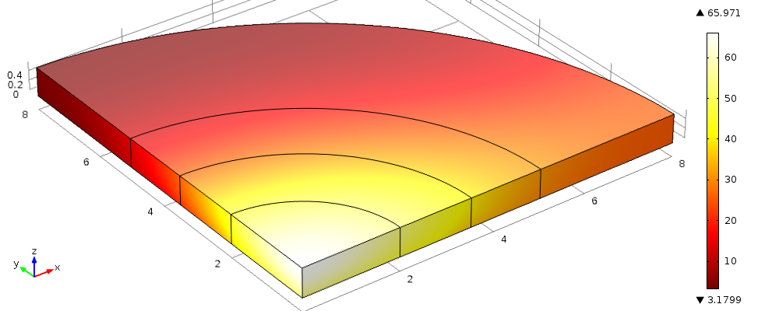

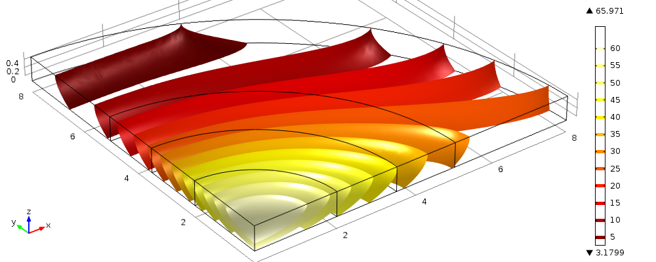
Fig. 4a&b: Total temperature rise ∆T in quadrant of 5.9-mm-thick beryllium window cooled on bottom face by 10 mm of helium flowing in x direction at 144 m/s; power density distribution q(r) as in Fig. 3c. Top: Surface temperature. Bottom: Isothermal contours. The maximum bulk temperature rise ∆T^{R} of 26°C in the helium is 16 times larger than it was in the water of Fig. 3, introducing considerable azimuthal nonuniformity to the temperature distribution.

